7.Create a simple cloud software application for Students Attendance System using any Cloud Service Provider to demonstrate SaaS include the necessary fields such as name of the students, course, present , Absent, course attendance, OD request, grade, attendance percentage, etc.

STEP1:

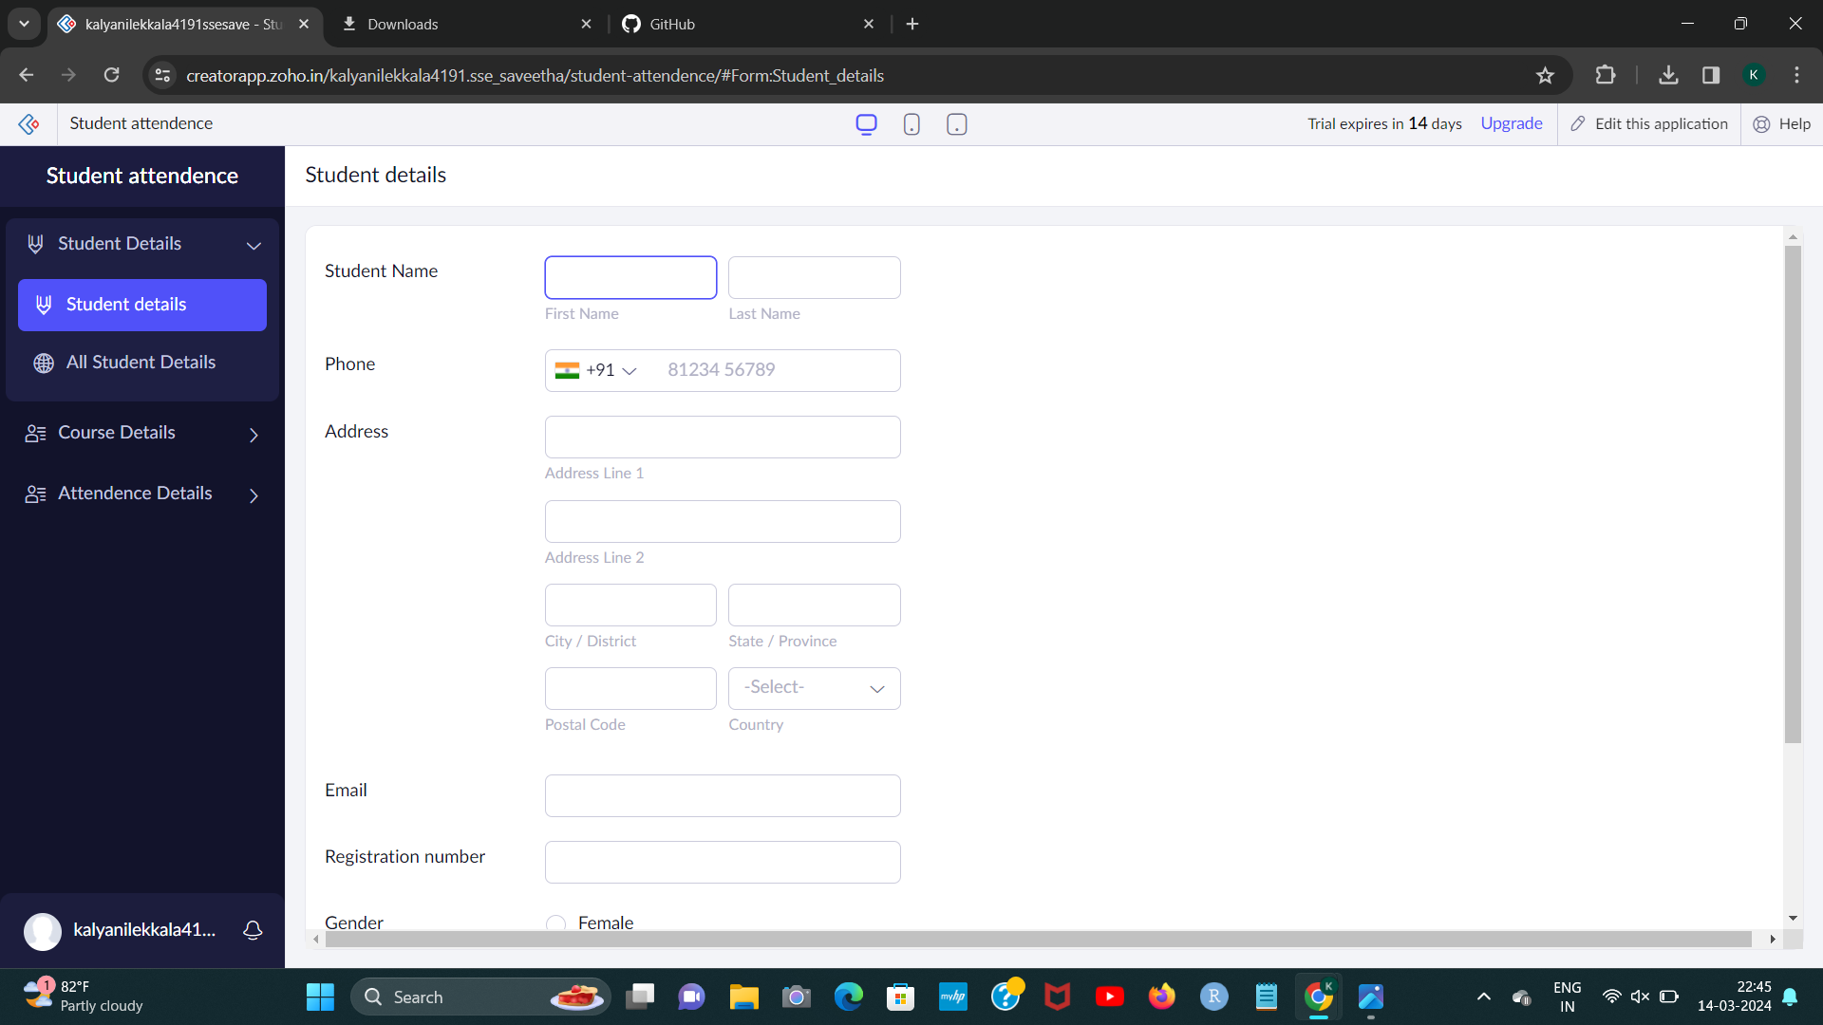

STEP2:

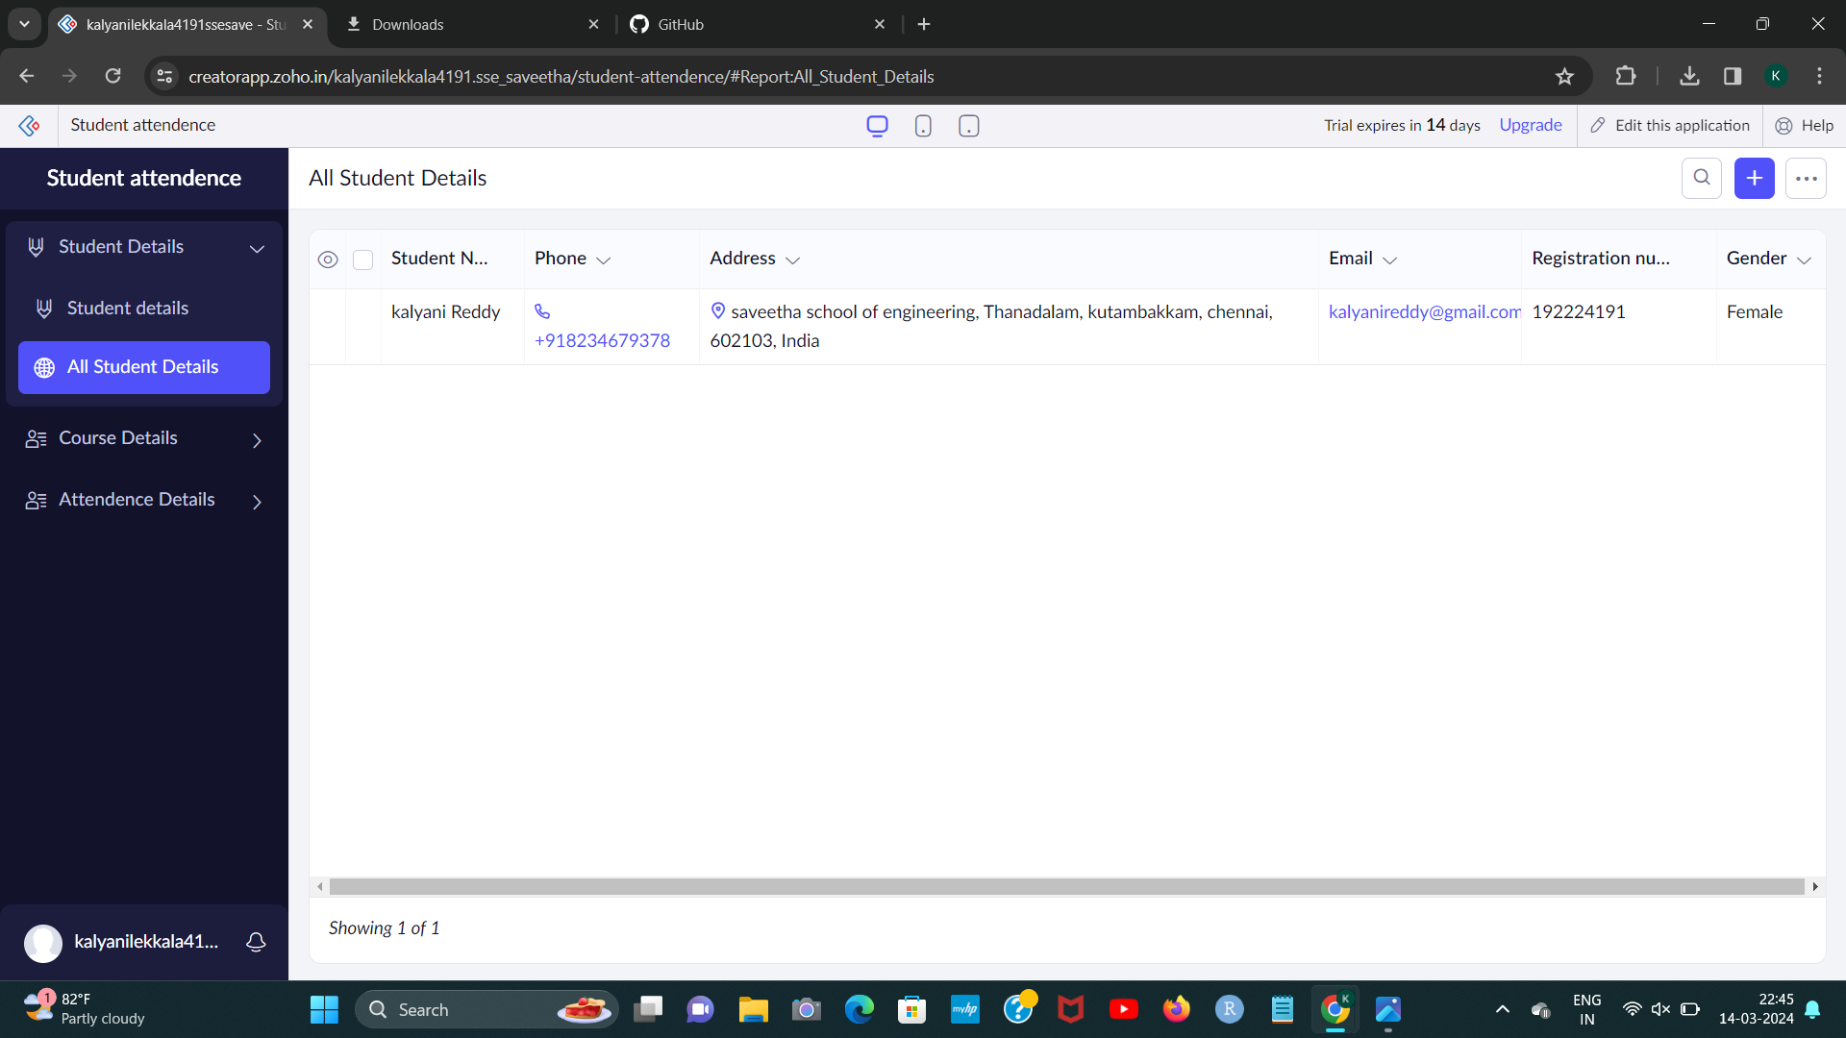[1]

STEP3:

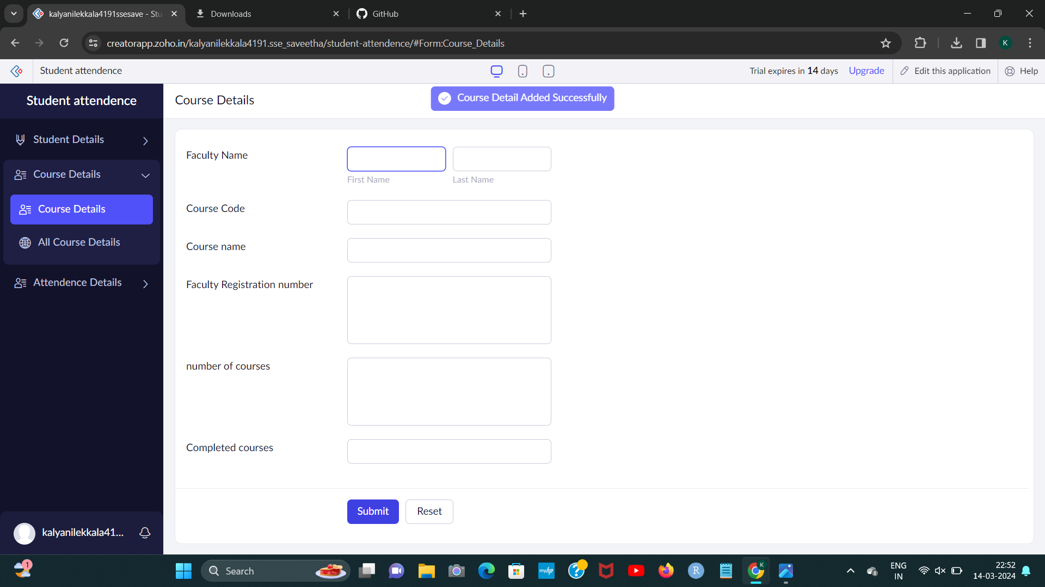

STEP4:

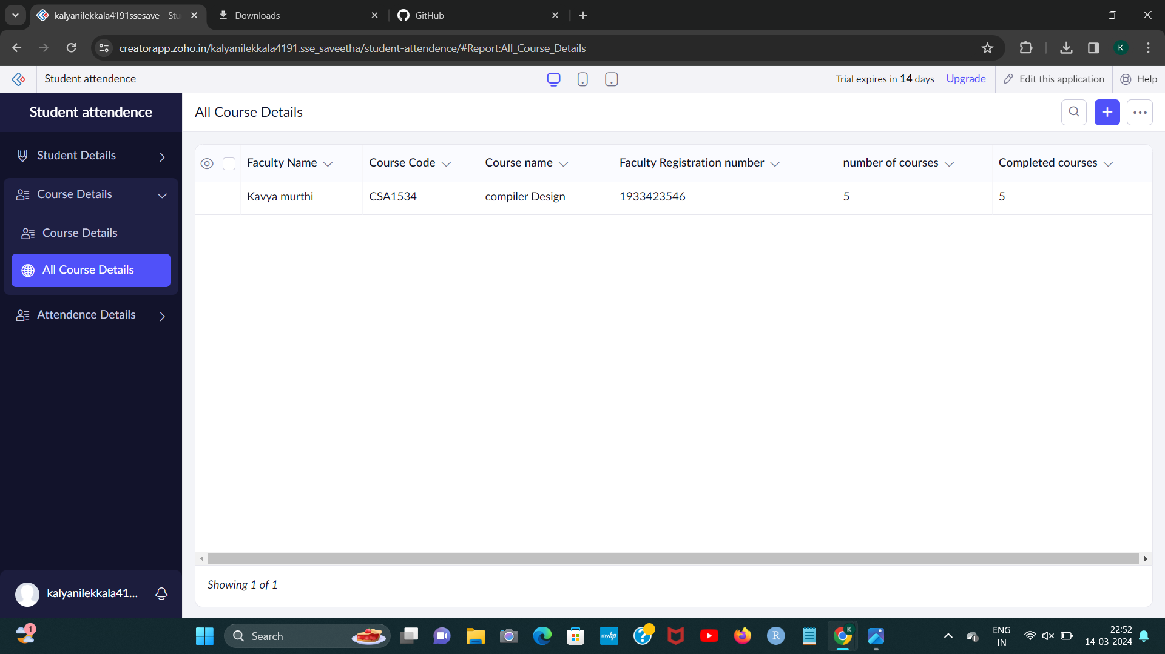

192224191 L.Kalyani

STEP6:

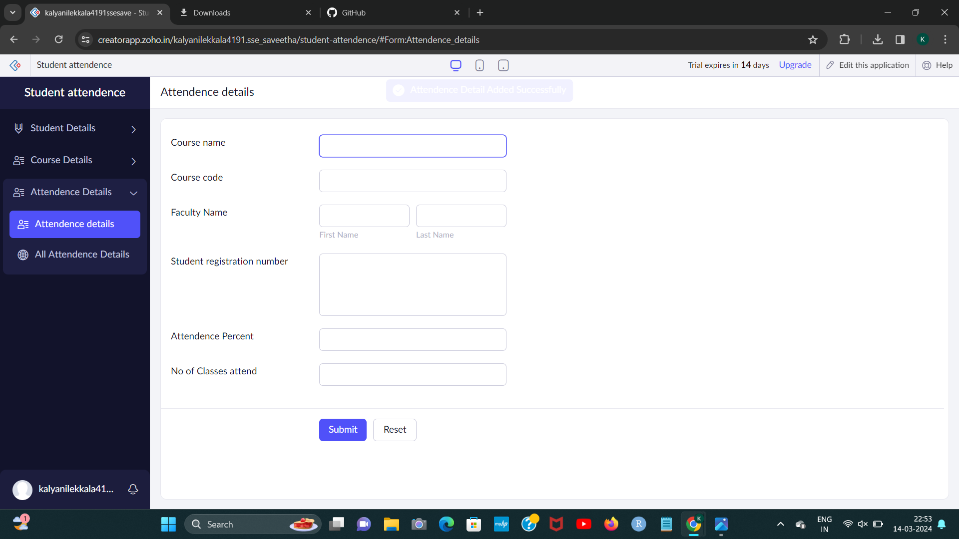

STEP7:

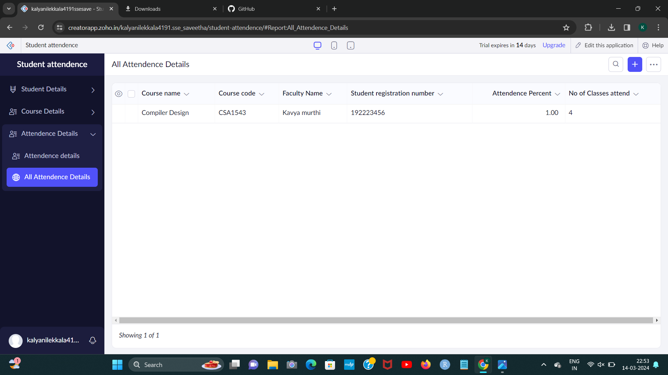[2]

1. 192224191 L.Kalyani
2. 192224191 L.Kalyani